PAYMENT OPTIONS FOR MUNICIPAL INVOICES
- Online Banking
- Call in with a credit card
- Send/Drop off cash or cheque
- In Person at the Township Office

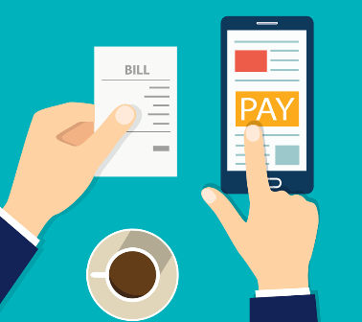
ONLINE BANKING :
Tax bills:
Add the Township of Black River-Matheson tax as a payee
Enter your Roll # found at the top of your invoice, make
sure to add the letter “T” in front of your Roll # to indicate
it’s taxes
EXAMPLE: T5614_ _ _ _ _ _ _ _ _ _ _ 0000

Utility bills:
Add the Township of Black River-Matheson water as a payee
Enter your Roll # found at the top of your invoice, make sure to add the letter W infront of your Roll # to indicate it’s utilities
EXAMPLE: W5614_ _ _ _ _ _ _ _ _ _ _ 0000

CALL IN WITH CREDIT CARD:
Have your credit card information ready and call the
Township office at (705) 273-2313 ext 313 or 314

SEND OR DROP OFF CASH OR CHEQUE:
Send payment clearly identifying your Roll # and if it
is a payment for your taxes or utilities to:
Township of Black River-Matheson
PO Box 601
Matheson ON P0K 1N0

Or
Drop off payment to the Township office
drop box, located on the left side of the main
entrance door.

