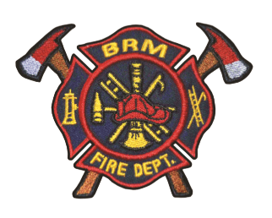
COVID-19 Fire Safety – Black River-Matheson Fire Department

Response

- Black River-Matheson Fire Department is ready to respond to Emergencies.

- When calling 911, please identify if anyone associated with the emergency has Covid 19 or is in self isolation.

- Please practice physical distancing when interacting with Firefighters.

Smoke alarms

- Lots of info on social media on how to stay productive and mentally healthy while working from home or self-isolating. Don’t forget to stay fire safe as well by testing your smoke alarms and reviewing your home fire escape plan.
- Whether you’re home for self-isolation or just practicing good physical distancing, now is a good time to make sure your smoke alarms work. Push the test button to make sure your alarms are working. If the alarm fails to sound, check and replace batteries if necessary.

Carbon monoxide alarms
- Carbon monoxide can be deadly. Test your carbon monoxide alarms to make sure they are working.

Home Fire Escape Planning

- Looking for something to do with the kids this week? Why not talk about your home fire escape plan to make sure everyone knows how to get out safely in case of fire?
- Looking for a safe activity to get out of the house and still avoid crowds? Try practicing your home fire escape plan with everyone in the household.

Cooking

- With potential for more family members spending more time at home these days and perhaps more cooking than normal, the need to remain alert in the kitchen is just as important as always. Prevent unattended cooking fires. Always stay in the kitchen while cooking.

- All kinds of learning opportunities exist for kids around the house. Take time to teach them about fire safety in the kitchen. Keep things that can burn away from stovetops.

Electronics

- Whether binge watching your favourite show or just surfing the web, lap tops should be used on flat, hard surfaces to allow internal fans to circulate airflow and keep devices from overheating.

- Surfing the web and playing games on your electronic devices while physical distancing with the family this week? Remember not to charge your electronic devices under your pillow, on your bed or upholstered furniture. They could overheat, and that’s not cool!

- Use proper charge cables to recharge electronic device like mobile phones, tablets, e-readers, and laptops. Avoid overloading electrical circuits.

